EXERCISE 13.2

Question 1:

The following table shows the ages of the patients admitted in a hospital during a year.  
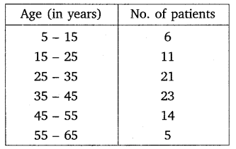

Solution:

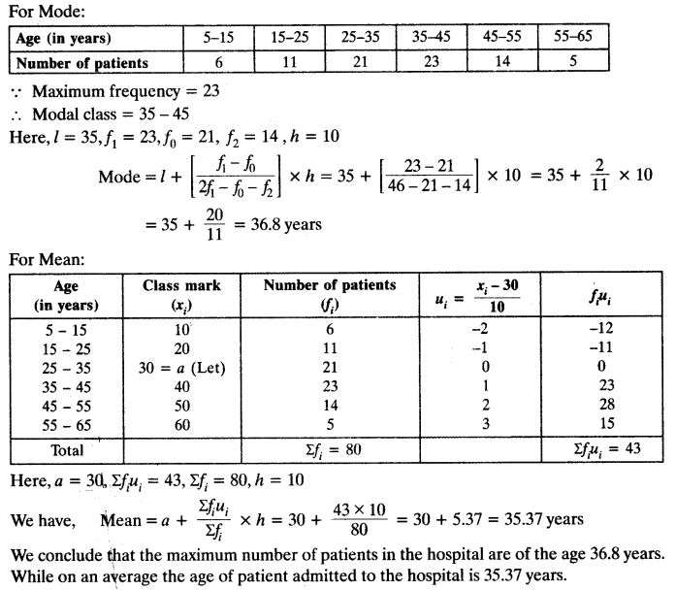

Question 2:

The following data gives information on the observed lifetimes (in hours) of 225 electrical components:  
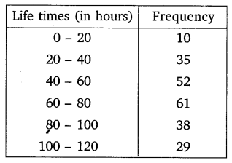

Solution:

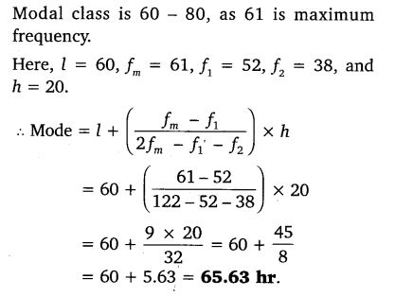

Question 3:

The following data gives the distribution of total monthly household expenditure of 200 families of a village. Find the modal monthly expenditure of the families. Also, find the mean monthly expenditure:  
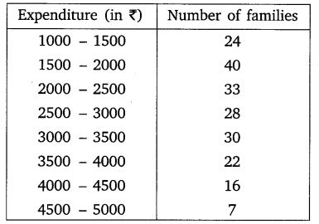

Solution:

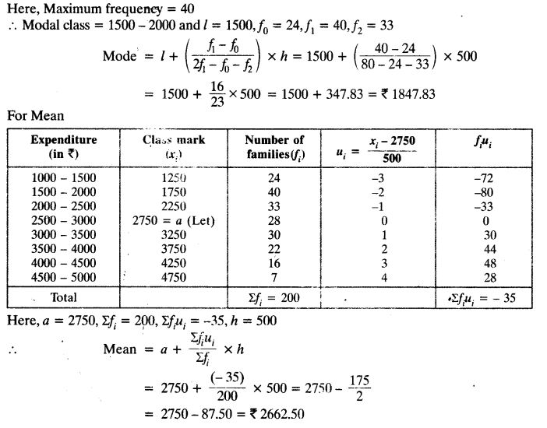

Question 4:

The following distribution gives the state-wise teacher- student ratio in higher secondary schools of India. Find the mode and mean of this data. Interpret the two measures.  
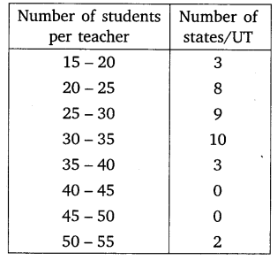

Solution:

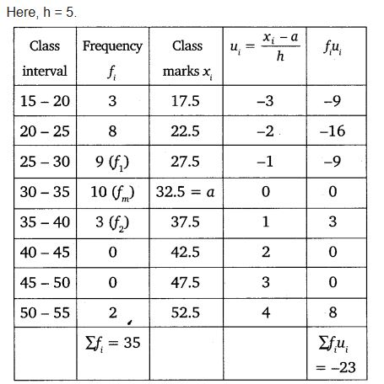

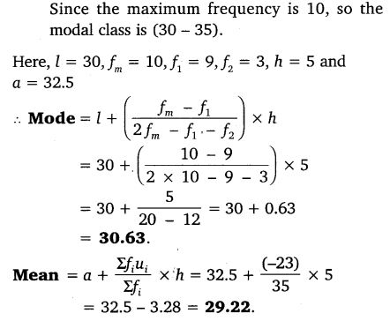

Question 5:

The given distribution shows the number of runs scored by some top batsmen of the world in one-day international cricket matches.  
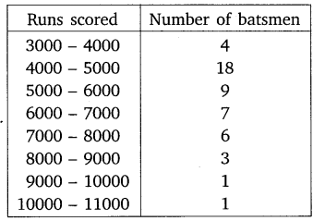

Solution:

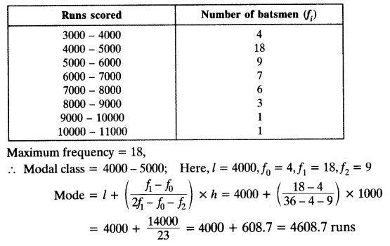

Question 6:

A student noted the number of cars passing through a spot on a road for 100 periods each of 3 minutes and summarised it in the table given below. Find the mode of the data:  
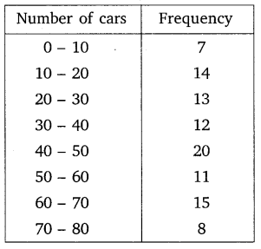

Solution:

